**CRUD OPERATION WEB APPLICATION**

**PROJECT DESCRIPTION:**

The CRUD Operation Web Application is designed to allow users to perform Create, Read, Update, and Delete operations on a simple user database. This project is useful for managing user information, such as names, email addresses, and phone numbers, in a user-friendly and visually appealing interface.

**PURPOSE:**

The primary purpose of this project is to provide a web-based solution for managing user data, demonstrating the implementation of CRUD operations with HTML, CSS, and JavaScript. This application serves as a learning tool for understanding how to manipulate and display data dynamically on a webpage.

**KEY FUNCTIONALITIES:**

1. **ADD USER:**
   * Users can add new entries by entering their name, email, and phone number.
   * Validation is performed to ensure the name contains only letters, and the phone number is exactly 10 digits.
2. **READ USER DATA:**
   * The application displays a list of all users in a table format.
   * Users' data, including their name, email, and phone number, are shown in separate columns.
3. **UPDATE USER INFORMATION:**
   * Users can modify an existing entry by clicking the "Modify" button next to the respective entry.
   * The selected user data is populated into the form fields, allowing the user to update the information.
4. **DELETE USER:**
   * Users can delete an entry by clicking the "Delete" button next to the respective entry.
   * The selected entry is removed from the table and the underlying data.

**TECHNOLOGY STACK:**

* **FRONTEND:**
  + **HTML5:** For structuring the content of the application.
  + **CSS3**: For styling the user interface, including layout, colors, and animations.
  + **JavaScript:** For handling the logic behind the CRUD operations, form validation, and dynamic content manipulation.

**USER INTERFACE DESIGN:**

* The application features a modern and responsive design, with a gradient background and animations to enhance the visual appeal.
* Form inputs are styled with rounded corners, and buttons are designed with hover effects to improve user interaction.
* The table displaying user data is centered and styled to ensure readability and consistency across different screen sizes.

**VALIDATION AND ERROR HANDLING:**

* The form includes client-side validation to ensure that user input meets specific criteria (e.g., name must contain only letters, phone number must be 10 digits).
* Visual feedback is provided to users when input is valid or invalid, with appropriate border colors indicating the status.

**FUTURE ENHANCEMENTS:**

* **BACKEND INTEGRATION:**  
  Implementing a backend with a database to store user data persistently.
* **USER AUTHENTICATION:**  
  Adding login and registration features to manage user access.
* **ADVANCED FEATURES:**  
  Implementing search, sorting, and filtering capabilities for the user data.

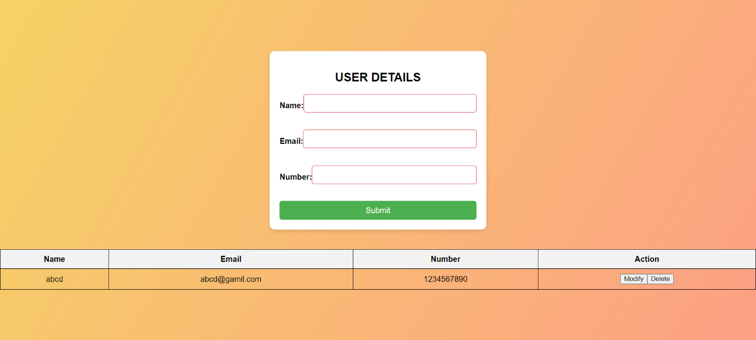**SCREENSHOTS:**

**CONCLUSION:**

The CRUD Operation Web Application is a comprehensive project that showcases the essential operations required for managing user data in a web environment. The application is designed with a focus on user experience and provides a solid foundation for further development and enhancements.